

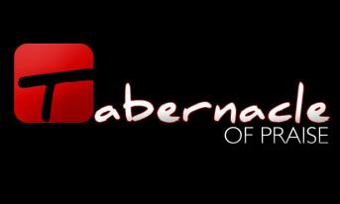
your-url-goes-right-here.com


Do We Really Have a Group for You?

Regardless of your age, interest, or location, we are sure that we have a Life Group out there for you. We also have 3 different types of “Free Market” Life Groups which include:

- Curriculum-Based: This is where the host uses an approved formal curriculum through us at the Tabernacle of Praise.
- Interest-Based: This can be anything from: outdoors, shopping, running, Monday Night Football, exercise, etc.
- Both: A Life Group can also be an interest-based group that uses a formal curriculum.
If you would like to join a Life Group, simply visit the “Life Group Master Curriculum Form” tab on our church’s main website (listed below), or you can visit the Information Center to get a printed directory (located in the atrium) at the Tabernacle of Praise.
So what are you waiting for? Join a Life Group and starting growing today!

When are Life Groups offered throughout the year?

Life Groups are typically offered 3 times throughout the year:

  - Fall Semester: Begins the first week of September

  - Spring Semester: Begins the first week of February

  - Summer Semester: Begins the first week of June

For more information, please feel free to contact the Life Group’s Pastor (Kevin Dingess)

Phone:
(304) 992-1606

E-mail: KevinDingess@hurricanechurch.com

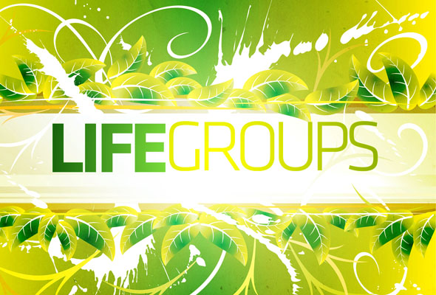

.

ph 304.562.9168 | http://hurricanechurch.com/#/life-groups

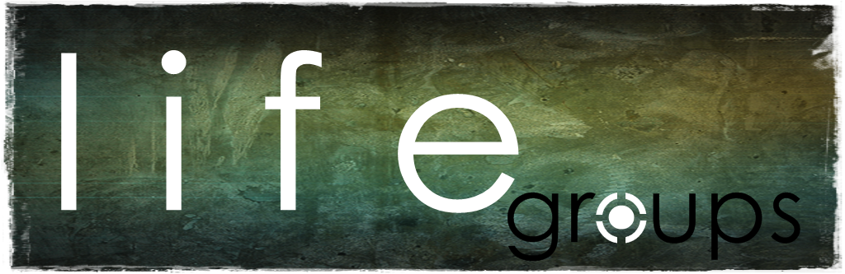
Tabernacle of praise (Life Groups)
2368 Thomson Rd.
Culloden, WV 25510

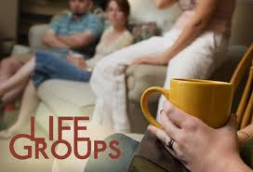
2638 Thompson Rd.
Culloden, WV 25510
http://hurricanechurch.com/#/life-groups/life-groups
Why should I Join a Life Group?

Life Groups are your key to developing connections with those who share your common interests, or people who are dealing with similar life situations.

8 Central Hubs:
- Student
- Men
- Women
- Marriage/Family

8 Central Hubs:
- Prayer
- Finances
- L.I.F.E (Living in Freedom Everyday)
- Outreach

What are Life Groups?

A Life Group is a group of people who come together on a regular basis for a common purpose, and are led by hosts. Hosts assist the group members in reaching their full devotion and potential in Christ by intentionally facilitating an environment for connection, community, and spiritual growth.

We believe, at the TOP, that real life change happens best in the context of authentic relationships. Our "Free-Market" Life Groups meet once a week in places all around our region and provide a place for you to connect, grow, and discuss the challenges of life.
Do Life Groups Do Anything to Help Others?

Throughout the semester, the Life Group will have 1 “Community Outreach Project” and 1 “Fellowship Event” week.
The Community Outreach Project (COP) gives you the opportunity to help those in need in our local community.

COPs can range from something very small to something really large such as: donating baby clothes, helping feed the homeless, fixing up someone’s home, taking a meal to the local fire department, etc. The opportunities are nearly limitless. Each Life Group will choose their own COP that they wish to do.

The Fellowship Event week allows you the opportunity to build better relationships with those in your group. This is where the group breaks away from formal curriculums or interest and has a time of fellowship together for one evening such as: eating at a restaurant, bowling, movies, sporting events, cookouts, etc. This event is specifically designed to help you get to know the people in your group better and build meaningful life-long relationships.

